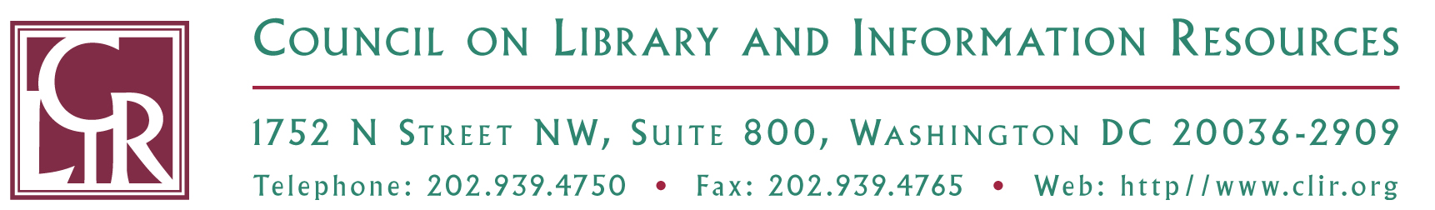

Leadership through New Communities of Knowledge

Support Statement for Team Application to Attend Undergraduate Research Behavior Workshop at Rollins College, November 2010

Name of First Team Member:
Official Job Title:
Name of Second Team Member:
Official Job Title:
Institution:

Name of Authorizing Official:
Job Title:

I affirm that I support the above-named applicants’ application to attend the Undergraduate Research Behavior workshop.

Signature

Date

Save completed and signed form as a PDF and include the applicants’ names in the document title. Submit to newcommunities@clir.org by 5:00 PM EDT, September 15, 2010.

